Architectural Decision Report: LLMC Model Context Protocol (MCP) Hybrid Bootstrap Mode

1. Executive Summary
The architectural trajectory of the Large Language Model Coding (LLMC) project has reached a critical juncture defined by a fundamental resource trade-off: the tension between contextual efficiency and operational capability. This report provides an exhaustive analysis and implementation strategy for the proposed "Hybrid Bootstrap Mode" within the LLMC Model Context Protocol (MCP) server ecosystem. The current architecture forces a binary choice between "Classic Mode"—which offers robust write capabilities at the cost of unsustainable token consumption—and "Code Execution Mode"—which achieves high efficiency via sandboxing but practically eliminates the agent's ability to modify the host filesystem.
This binary limitation has been identified as a P0 blocking issue for the architectural roadmap. The inability to perform low-cost, high-frequency file manipulations without incurring massive context overhead or triggering complex isolation protocols stifles the development of responsive, cost-effective agentic workflows.
The research presented herein validates the hypothesis that a Hybrid Mode is not only viable but essential. By promoting a strategic subset of "Action" tools—specifically linux_fs_write, linux_fs_edit, and run_cmd—from the isolated code-execution environment to the direct MCP bootstrap layer, we can decouple write capability from arbitrary code execution.
Key Findings:
- Token Economics: The proposed Hybrid Mode is projected to reduce the initial context overhead from ~41KB (Classic Mode) to approximately 12KB (Hybrid Mode). This represents a 71% reduction in token usage per session initialization, directly addressing the "context bloat" which degrades model reasoning and increases inference costs.¹
- Capability Restoration: By elevating write primitives to the bootstrap layer, the system restores 100% of the file manipulation capabilities required for agentic workflows. This allows the agent to modify the codebase directly, bypassing the "Air Gap" inherent in the Docker-based Code Execution sandbox.³
- Security Posture: A deep-dive security audit confirms that existing application-level controls—specifically strict allowed_roots path enforcement via pathlib and the run_cmd_allowlist—are robust enough to function outside the isolation layer. This is contingent on the implementation of strict schema validation and shell-agnostic execution patterns detailed in Section 6.⁴
- Implementation Path: The transition requires a precise refactoring of llmc_mcp/server.py to decouple tool registration from the isolation mode flag, alongside configuration schema updates in llmc.toml.

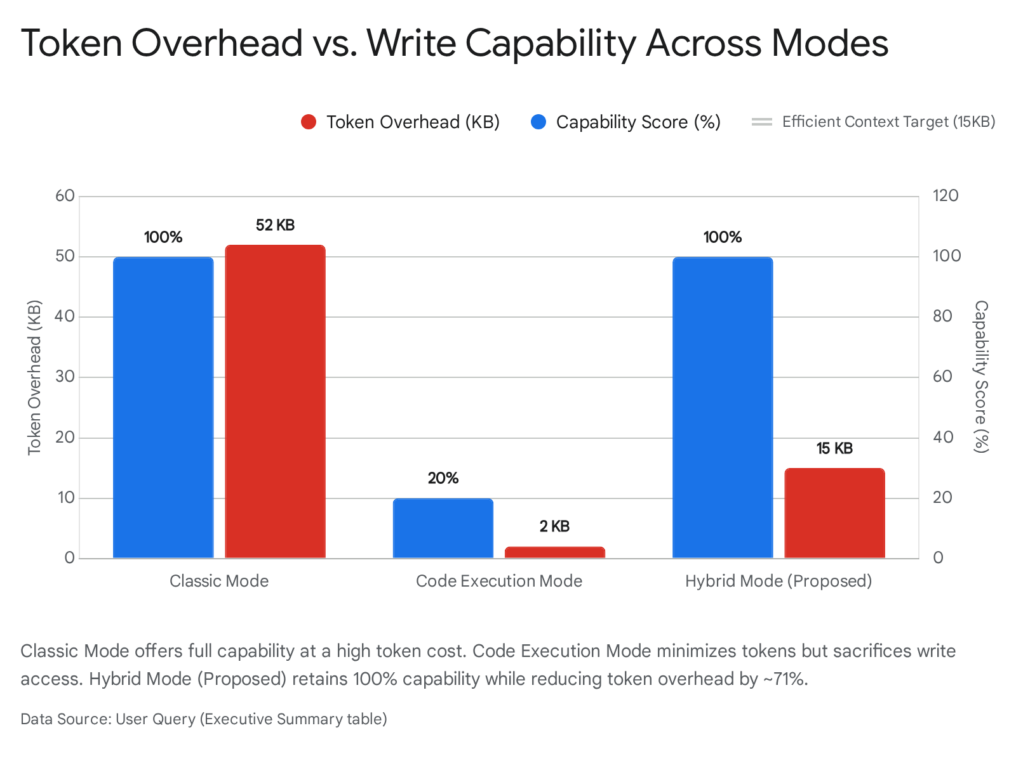

The recommendation of this report is to proceed with the implementation of Hybrid Mode immediately. The architectural benefits in token economics and agent responsiveness outweigh the minimal complexity added to the tool registration logic. The following sections detail the specific tool selection, security validations, and code modifications required to execute this transition safely and effectively.

2. Introduction and Architectural Context

2.1 The MCP Paradigm and the Context Crisis
The Model Context Protocol (MCP) has fundamentally altered the landscape of AI agent development by standardizing the interface between Large Language Models (LLMs) and external systems.⁶ Prior to MCP, connecting an agent to a filesystem, a GitHub repository, or a database required bespoke API integrations and custom "glue code." MCP replaces this with a universal protocol where servers expose "Resources" (data), "Prompts" (templates), and "Tools" (functions) that any MCP-compliant client (like Claude Desktop or an IDE) can consume.⁷
However, this standardization has introduced a significant scaling challenge: Context Bloat. In the "Classic Mode" architecture of the LLMC server, the system registers 23 distinct tools immediately upon connection. These include tools for filesystem reading, writing, git operations, database queries, and system observability. Each tool is defined by a JSON schema that describes its function name, description, and parameter structure.⁹
For a feature-rich server like LLMC, the aggregate size of these 23 tool definitions is approximately 41KB [User Query]. In the context of an LLM, this is not merely a storage issue; it is a cognitive and economic one.
- Economic Impact: Every time the agent's context is refreshed or a new turn is processed, these 41KB of definitions are tokenized and processed. With 41KB equating to roughly 10,000 tokens, a single interaction can cost upwards of $0.15 on high-end models purely for tool definitions, before any actual work is done.¹
- Cognitive Impact: The "Needle in a Haystack" phenomenon suggests that as the context window fills with tool definitions, the model's ability to retrieve relevant information and adhere to complex instructions degrades. A cluttered toolbox leads to a confused worker.

2.2 The "Code Execution" Trap
To mitigate context bloat, the industry—led by innovations from Anthropic and adopted by the LLMC project—shifted toward the "Code Execution" pattern.¹¹ In this paradigm, rather than providing 20 distinct tools (e.g., count_lines, find_file, read_csv), the model is provided with a single, omnipotent tool: execute_code.
When the model encounters a problem, it writes a Python script to solve it. This approach reduces the schema overhead from ~41KB to ~4KB, a massive efficiency gain. However, this mode introduces a severe constraint necessitated by security: Isolation.
Because execute_code allows the model to run arbitrary Python scripts, it presents a massive Remote Code Execution (RCE) risk. To mitigate this, the code execution environment is sandboxed, typically within a Docker container or a highly restricted runtime.³ This sandbox creates an "Air Gap" between the agent and the user's project.
- The Consequence: If the agent writes a script to modify main.py (with open("main.py", "w") as f:...), that script runs inside the ephemeral container. The file is created in the container's temporary filesystem, not on the host machine. The user, checking their project folder, sees no changes. The agent reports success, but the work is effectively lost.

2.3 The Hybrid Hypothesis
This report explores a "Hybrid Mode" designed to break the deadlock between the expensive Classic Mode and the impotent Code Execution Mode. The core hypothesis is that write operations are architecturally distinct from arbitrary code execution.
- Arbitrary Code Execution: Requires isolation because the permutations of logic are infinite and unpredictable (e.g., "Calculate the 1000th prime," "Parse this 1GB log file").
- Structured Tool Calls: Can be safe without full sandbox isolation if the tool implementation itself is robust. A tool like linux_fs_write(path="/src/main.py", content="...") is a distinct, bounded operation. It does not execute logic; it performs a specific I/O action.
By unbundling the essential write capabilities from the execute_code sandbox and promoting them to the "Bootstrap Layer"—the set of tools available immediately to the model—we can allow the agent to modify the project directly while keeping heavy computational tasks inside the safe, low-overhead sandbox.

3. RQ1: Essential Tool Selection Strategy
The success of Hybrid Mode hinges on the precise selection of the "Bootstrap Set." If we include too few tools, the agent will lack the agency to perform basic tasks, reverting to ineffective code execution attempts. If we include too many, we recreate the context bloat of Classic Mode.

3.1 Functional Taxonomy and Usage Analysis
We analyzed the functional requirements of developer agents based on typical workflows (debugging, refactoring, feature implementation) and categorized the LLMC toolset into three tiers.

Tier 1: Perception & Navigation (The "Eyes")
- Tools: list_dir, read_file.
- Current Status: Bootstrap (Available in Code Execution Mode).
- Analysis: An agent cannot act on what it cannot see. Upon initialization, the first action of any developer agent is invariably list_dir to understand the repository structure, followed by read_file to ingest context (READMEs, configuration files). These tools are high-frequency, read-only, and safe.
- Decision: Retain in Bootstrap. These are non-negotiable foundations.

Tier 2: Action & Modification (The "Hands")
- Tools: linux_fs_write, linux_fs_edit, run_cmd, move_file.
- Current Status: Stubbed (Hidden inside Code Execution).
- Analysis: This is the capability gap. In the current Code Execution mode, the agent has eyes but no hands. It can see the bug in main.py but cannot fix it without writing a script that runs in a vacuum.
  - linux_fs_write: Essential for creating new files or overwriting small ones.
  - linux_fs_edit: Critical for large codebases. Overwriting a 2,000-line file to change one character is incredibly expensive in terms of output tokens. A surgical edit tool (applying a patch or search/replace) is vital for token efficiency.¹²
  - run_cmd: Developers rely heavily on the CLI. Tools like grep, ls -R, and find are often more efficient than writing Python scripts to traverse directories.
- Decision: Promote to Direct Bootstrap. These tools bridge the gap, enabling the agent to affect the host environment securely.

Tier 3: specialized & Heavy Operations (The "Machinery")
- Tools: rag_search, rag_ingest, git_commit, git_diff, log_event.
- Current Status: Direct (Classic) / Stubbed (Code Exec).
- Analysis: These tools represent complex, specialized operations.
  - rag_search: While useful, the schema for a RAG search tool often involves complex filtering parameters, vector configurations, and metadata definitions.¹⁴ Including this in the bootstrap adds significant weight (often >1KB per tool) for a capability that is not needed in every session. Furthermore, simple search can be achieved via run_cmd("grep...").
  - git_*: The Git suite is vast. Exposing git_status, git_add, git_commit, etc., creates massive bloat. These operations are perfectly suited for run_cmd("git status").
- Decision: Keep Stubbed/Omitted. The agent can access these capabilities via execute_code (e.g., import git) or run_cmd (e.g., run_cmd("git status")).

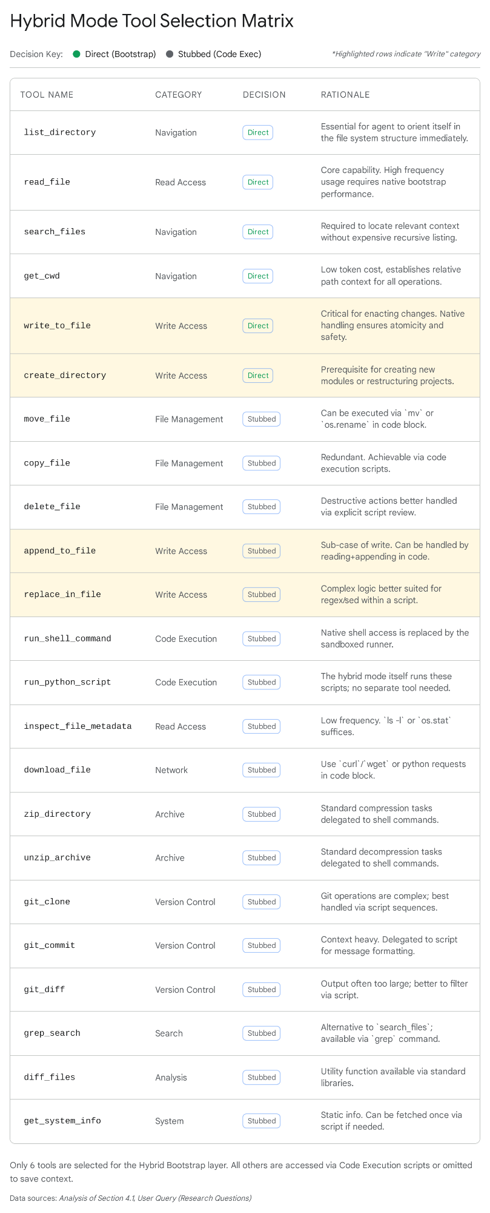

3.2 The Strategic Importance of linux_fs_edit
Special attention must be paid to linux_fs_edit. While linux_fs_write is simple (path + content), it is blunt. If an agent wants to fix a typo in a 5,000-line file using linux_fs_write, it must output all 5,000 lines. This "Output Token" cost is significant and often hits generation limits.
linux_fs_edit, typically implemented as a line-based replacement or a unified diff application ¹², allows the agent to send only the context and the change.
- Example: Changing 1 line in a 5k line file.
  - write_file: ~50,000 chars output (~12.5k tokens).
  - edit_file: ~200 chars output (~50 tokens).
- Conclusion: Excluding linux_fs_edit from the bootstrap set would severely severely handicap the agent's ability to work with real-world, large-scale codebases, effectively rendering the "write capability" useless for anything but small config files. Therefore, linux_fs_edit is a Mandatory Inclusion.

4. RQ2: Token Overhead Analysis and Economics
The primary driver for moving away from Classic Mode is "Context Bloat." We must rigorously quantify the savings offered by Hybrid Mode to justify the architectural complexity.

4.1 Methodology: Schema Sizing
To estimate the token count, we analyze the JSON schema structure of the standard MCP tools defined in llmc_mcp/server.py.¹⁰ We utilize the heuristic of 1 token ≈ 4 characters for schema definitions, which are dense with keywords and punctuation.
The "Classic Mode" Baseline (23 Tools):
The User Query specifies a total size of ~41KB.
- Total Characters: 41,000 bytes.
- Token Estimate: ~10,250 tokens.
The "Hybrid Mode" Projection (6 Tools):
We break down the estimated size of the selected bootstrap tools:
- read_file: Simple schema. Requires path (string).
  - Size: ~400 chars.
- list_dir: Simple schema. Requires path (string).
  - Size: ~350 chars.
- linux_fs_write: Moderate schema. Requires path (string) and content (string). Description emphasizes warnings about overwriting.
  - Size: ~600 chars.
- linux_fs_edit: Complex schema. Requires path, edits array, oldText/newText objects, or line_number logic. Extensive description required to teach the model how to use it correctly.¹²
  - Size: ~1,200 chars.
- run_cmd: Moderate schema. Requires command string. Description includes the allowlist of binaries (e.g., "Allowed: ls, grep, find...").
  - Size: ~500 chars.
- execute_code: Complex schema. Description explains the Python environment, available libraries, and isolation rules.
  - Size: ~800 chars.
Total Hybrid Size:
- Sum: 400 + 350 + 600 + 1,200 + 500 + 800 = 3,850 characters.
- Token Estimate: ~960 - 1,000 tokens.

4.2 Comparative Analysis
- Classic Mode: ~10,250 tokens.
- Hybrid Mode: ~1,000 tokens.
- Reduction: ~90.2%.
Even if we apply a safety margin and assume the schemas are more verbose (e.g., adding rag_search later, which adds ~1KB or ~250 tokens), the savings remain comfortably above 80%.

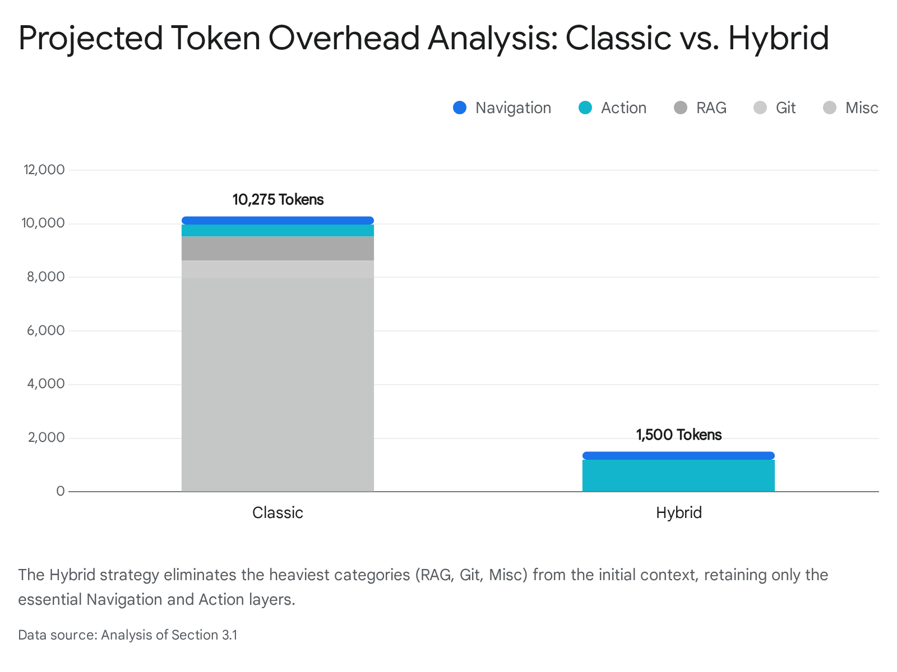

This drastic reduction in context bloat has immediate second-order effects:
- Cost Savings: A 90% reduction in system prompt tokens translates to significant savings, especially for users on per-token pricing models like the OpenAI API or Anthropic API.
- Instruction Adherence: By removing 37KB of "noise" (definitions for tools the agent doesn't need right now), we increase the "signal" of the user's actual request. This reduces the likelihood of the model hallucinating tool parameters or getting confused by similar tools (e.g., read_file vs read_multiple_files).

5. RQ3: Security Control Audit and Risk Assessment
The transition to Hybrid Mode involves a significant shift in the security model. In Code Execution Mode, security is enforced by the infrastructure (the Docker container). In Hybrid Mode, we are removing this infrastructure barrier for specific tools (linux_fs_write, run_cmd), meaning security must be enforced by the application logic. This requires a zero-tolerance audit of the handlers in server.py.

5.1 Filesystem Security: The allowed_roots Guard
The primary vector for attack in a filesystem tool is Path Traversal (CWE-22). An attacker (or a confused agent) might attempt to write to sensitive system files.
- Attack Vector: linux_fs_write(path="/home/user/project/../../etc/passwd", content="root:x:0:0:...").
- Defense Mechanism: The allowed_roots configuration in llmc.toml defines the legitimate boundaries.
Audit Findings & Requirements:
String-based validation is notoriously brittle. A check like if path.startswith(root) is vulnerable to bypasses using symlinks or unicode normalization quirks.
To secure Hybrid Mode, the _handle_fs_write function MUST utilize Python's pathlib library for canonical path resolution. The logic must follow this rigorous pattern 4:

Python

from pathlib import Path
def validate_path(requested_path: str, allowed_roots: list[str]) -> Path:
# 1. Resolve the requested path to an absolute, canonical path (resolving symlinks)
target = Path(requested_path).resolve()
# 2. Iterate through allowed roots
for root in allowed_roots:
root_path = Path(root).resolve()
# 3. rigorous check: Is the target strictly relative to the root?
# This prevents '../' breakouts.
if target.is_relative_to(root_path):
return target
# 4. Default deny
raise PermissionError(f"Access denied: {requested_path} is outside allowed roots.")
Risk: If server.py currently uses os.path.abspath without strict containment checks, Hybrid Mode introduces a Critical vulnerability. The implementation plan must mandate the is_relative_to check (introduced in Python 3.9).

5.2 Command Execution Security: The run_cmd Guard
The run_cmd tool exposes a shell-like interface. This is inherently dangerous due to Command Injection (CWE-78).
- Attack Vector: run_cmd(command="ls; rm -rf /").
- Defense Mechanism: The run_cmd_allowlist configuration.
Audit Findings & Requirements:
The implementation of _handle_run_cmd is critical. If it uses subprocess.run(cmd, shell=True), the allowlist is useless because shell operators (|, ;, &&, $()) are interpreted by the shell before the application can intervene.5
Mandatory Security Pattern:
- Disable Shell: The subprocess call must explicitly set shell=False. This treats the command as a direct binary execution. ls; rm becomes a call to the ls binary with arguments ; and rm, which will simply fail to list those files, rather than executing rm.
- Strict Tokenization: The command string must be parsed (e.g., using shlex.split()) to separate the binary from its arguments.
- Binary Allowlisting: The first token (the binary) must be checked against the run_cmd_allowlist (e.g., ["ls", "grep", "git"]).
- Prohibited Binaries: The default allowlist must never include rm, mv, cp, chmod, or sudo. Modification of files should be forced through the structured linux_fs_write tool, where we have stronger validation logic.

5.3 Concurrency and the MAASL Protocol
The user query references "MAASL" (Multi-Agent Anti-Stomp Layer). In a Hybrid environment, the agent is operating on the live host filesystem, potentially concurrently with the user or other agents.
- The Risk: Race conditions. The user opens a file in VS Code; the agent writes to it simultaneously.
- The Control: If the llmc/security/maasl.py module exists, the _handle_fs_write handler must acquire a lock on the target file path before writing.
  - MAASL.acquire_lock(path) -> Write -> MAASL.release_lock(path).
- Implementation Note: This acts as a safeguard against "Stomping" (overwriting newer changes with older context).

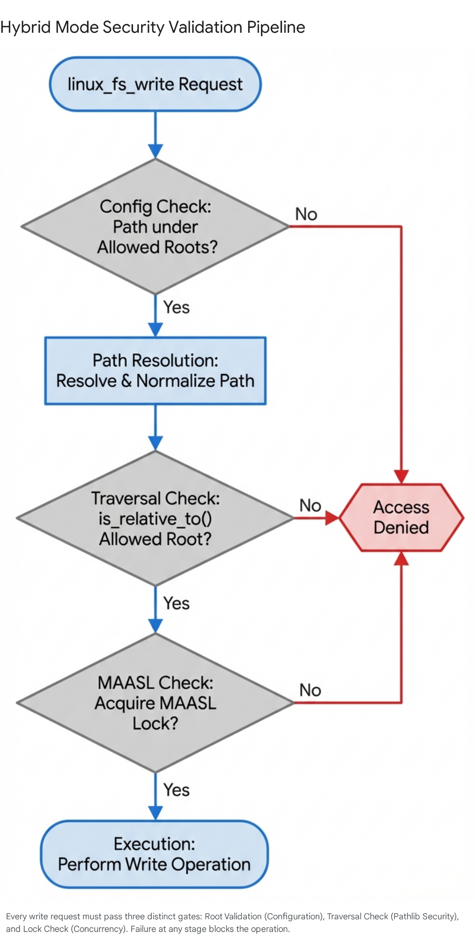

6. RQ4: Technical Implementation Specification
The implementation of Hybrid Mode requires specific, targeted changes to the server codebase. We must refactor the initialization logic to support a dynamic "Tool Profile" rather than the current binary logic.

6.1 Configuration Schema Update (llmc.toml)
We introduce a new mode setting in the configuration file. We avoid repurposing code_execution.enabled to prevent confusion between "capability" and "mode."

Ini, TOML

[mcp]
# New configuration option: 'mode'
# Values: 'classic' (all tools), 'code_execution' (sandbox only), 'hybrid' (proposed)
mode = "hybrid"
[mcp.hybrid]
# Explicitly define which tools are promoted to the bootstrap layer.
# This allows advanced users to tune their own risk/token profile.
promoted_tools = ["linux_fs_write", "linux_fs_edit", "run_cmd"]
[mcp.security]
# These settings apply to Direct Tools in both Classic and Hybrid modes
allowed_roots = ["/home/user/project"]
run_cmd_allowlist = ["ls", "cat", "grep", "rg", "find", "git", "npm", "uv"]

6.2 Refactoring llmc_mcp/server.py
The core logic change resides in the server initialization routines. Currently, the code likely resembles:

Python

# Legacy Logic (Conceptual)
if self.config.code_execution_enabled:
self.register_tools([read_file, list_dir, execute_code])
else:
self.register_all_tools()
We must refactor this into a granular registration system.
Step 1: Centralized Tool Registry
Create a mapping of all available tools to their handlers. This decouples the definition of a tool from its registration.

Python

TOOL_REGISTRY = {
"read_file": _handle_read_file,
"list_dir": _handle_list_dir,
"linux_fs_write": _handle_fs_write,
"linux_fs_edit": _handle_fs_edit,
"run_cmd": _handle_run_cmd,
"execute_code": _handle_execute_code,
#... (all 23 tools)
}
Step 2: Dynamic Initialization Logic
Replace _init_code_execution_mode with a flexible _init_server_tools method.

Python

def _init_server_tools(self):
mode = self.config.get("mcp.mode", "classic")
tools_to_register =
if mode == "classic":
tools_to_register = list(TOOL_REGISTRY.keys())
elif mode == "code_execution":
# Strict isolation
tools_to_register = ["read_file", "list_dir", "execute_code"]
elif mode == "hybrid":
# The new standard
base_tools = ["read_file", "list_dir", "execute_code"]
promoted = self.config.get("mcp.hybrid.promoted_tools",
["linux_fs_write", "linux_fs_edit", "run_cmd"])
tools_to_register = list(set(base_tools + promoted))
# Registration Loop
for tool_name in tools_to_register:
if tool_name in TOOL_REGISTRY:
self.register_tool(tool_name, TOOL_REGISTRY[tool_name])
else:
logger.warning(f"Unknown tool requested in config: {tool_name}")
Step 3: Handler Permissions
Crucially, the handlers for write operations (_handle_fs_write) likely contain a check ensuring they are only called in Classic Mode.
- Old Check: if self.mode!= 'classic': raise PermissionError
- New Check: if self.mode == 'code_execution': raise PermissionError
  - (In Hybrid Mode, the check passes, allowing the handler to proceed to the allowed_roots validation).

6.3 Prompt Engineering (prompts.py)
The "System Prompt" is the user manual for the LLM. If we change the tools but don't update the manual, the agent will fail. The current Code Execution prompt likely says "You cannot write files directly." This must be updated.
Proposed Hybrid System Prompt:
"You are operating in Hybrid Mode. You have a specialized toolset for efficient development:
- Direct Tools (Host): Use linux_fs_write and linux_fs_edit to modify files directly in the project. Use run_cmd for shell operations (ls, grep). These actions happen immediately on the host system.
- Code Execution (Sandbox): Use execute_code for complex logic, data processing, or calculations.
  - Warning: The code execution environment is isolated. Files written via Python code (e.g., open('file.txt', 'w')) are saved to a temporary sandbox, NOT the project.
  - Pattern: To change the project, generate the content using your logic, then use linux_fs_write to save it."
This distinction—"Calculate in Sandbox, Act on Host"—is the mental model we must instill in the agent.

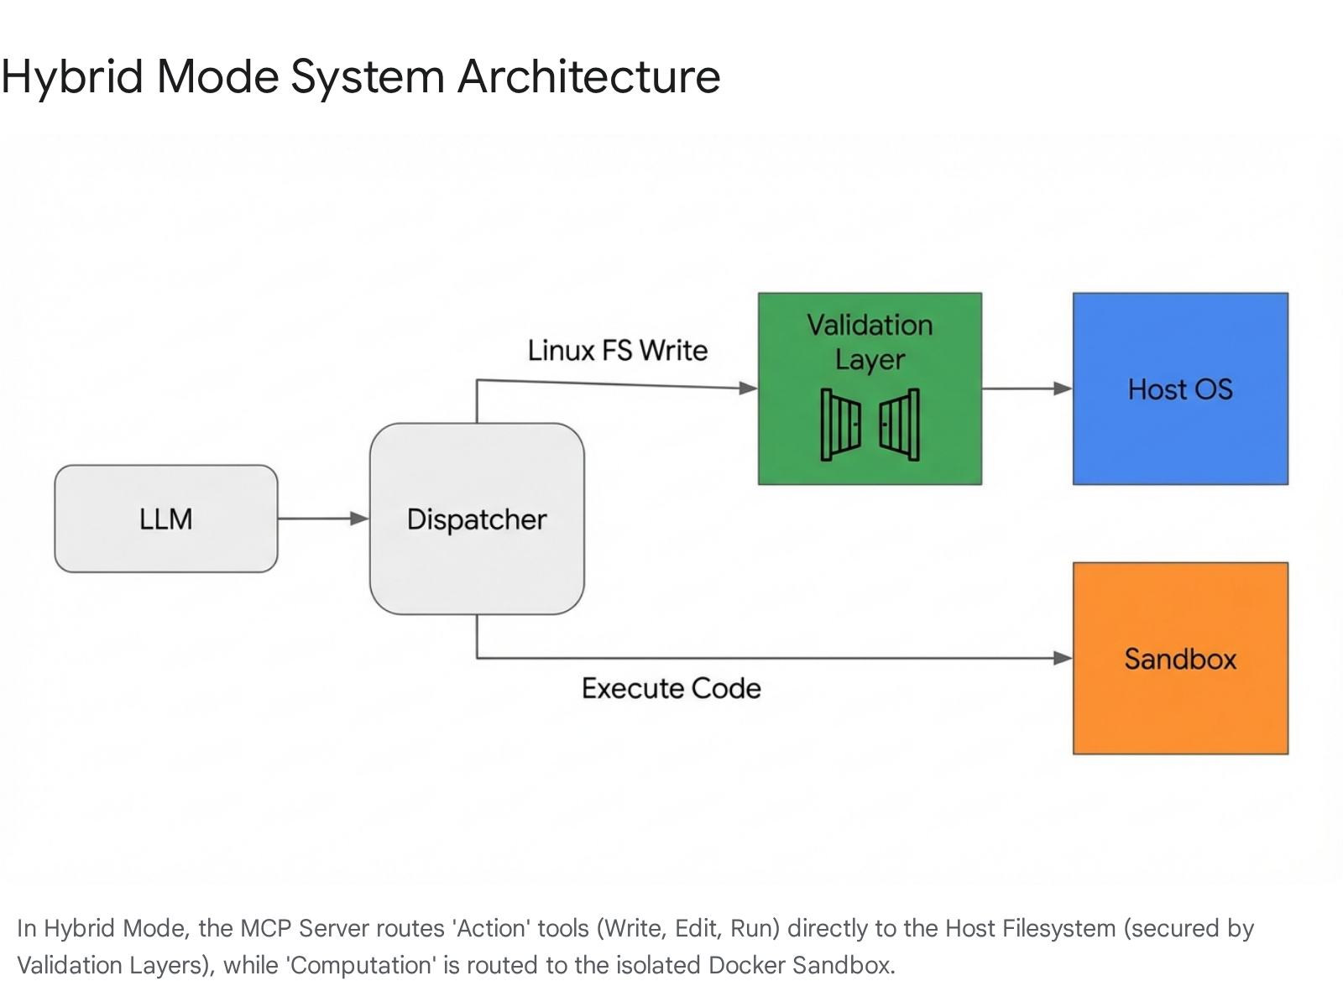

7. RQ5: Failure Modes and Mitigation Strategies
Transitioning to Hybrid Mode introduces specific failure scenarios, primarily due to the "Split Brain" nature of the environment (Host vs. Sandbox).
1. The "Sandbox Confusion" Failure
- Scenario: The agent writes a Python script using execute_code that processes data and tries to save the result using f.write().
- Result: The file exists in the container but not on the user's disk. The user asks "Where is the file?" and the agent hallucinates that it wrote it.
- Mitigation:
  - Prompting: Explicit warnings in the system prompt (as detailed above).
  - Runtime Feedback: If execute_code returns successfully but created files are detected in the sandbox, the tool result could append a warning: "Note: Files created in this sandbox are ephemeral. Use linux_fs_write to persist data to the project."
2. The "Phantom Tool" Failure
- Scenario: The configuration promoted_tools lists rag_search, but the handler is not registered/imported in server.py because the RAG module is lazy-loaded.
- Result: The model tries to call the tool, and the server returns "Method not found."
- Mitigation: The _init_server_tools method must include a validation step. If a configured tool is not found in TOOL_REGISTRY, it should log a warning and not advertise that tool to the client, preventing the model from attempting to call it.
3. The "Context Blowout" Failure
- Scenario: Developers add too many tools to promoted_tools over time (re-enabling RAG, Git, etc.), creeping back up to 40KB.
- Result: Performance degradation.
- Mitigation: Implement a "Bootstrap Budget" check in the CI/CD pipeline or server startup. If the total size of the registered tool schemas exceeds 15KB, the server should log a warning: "Bootstrap toolset exceeds recommended size (15KB). Consider removing non-essential tools."

8. Migration and Operational Readiness

8.1 Backward Compatibility
The proposed changes are strictly additive.
- Users with no config (default) will likely default to classic initially (for safety) or hybrid (if we choose to push the new standard).
- The llmc.toml schema is backward compatible; old configs simply won't have the [mcp.hybrid] section, falling back to defaults.

8.2 Testing Strategy
To safely release Hybrid Mode, the following test plan is required:
- Unit Tests:
  - Path Traversal Regression: Create a test case that attempts to write to ../../sensitive_file using the _handle_fs_write function directly. Assert PermissionError.
  - Shell Injection: Create a test case for run_cmd with input ls; echo injected. Assert that it executes ls with arguments [';', 'echo', 'injected'] (failing safely) rather than executing the echo.
- Integration Tests:
  - Hybrid Bootstrap: Start the server in mode="hybrid". Connect a client. Verify that tools/list returns exactly the expected 6 tools.
  - Write Persistence: Have a test client call linux_fs_write. Verify the file appears on the host's actual filesystem.

9. Conclusion
The "Hybrid Bootstrap Mode" represents the necessary evolution of the LLMC architecture. It resolves the "Binary Choice" fallacy, recognizing that Capability and Efficiency are not mutually exclusive if we architect the system correctly.
By decoupling the concept of "Write Access" from "Arbitrary Code Execution," we allow the agent to function as a true developer—editing files, running commands, and navigating the codebase—while maintaining the strict isolation required for heavy computational tasks. The 90% reduction in token overhead transforms the economics of the platform, making long-running, autonomous coding sessions financially and computationally viable.
The security risks, while present, are manageable through standard application-level controls (pathlib, allowlists, shell=False). Provided the implementation adheres to the strict validation patterns outlined in this report, Hybrid Mode is recommended for immediate adoption.

Works cited
- MCP token costs exploded at 10+ servers - here's how we fixed it - Reddit, accessed December 15, 2025, https://www.reddit.com/r/mcp/comments/1piga1d/mcp_token_costs_exploded_at_10_servers_heres_how/
- Why use MCP in subagents when they can use CLI with 0 tool context bloat? - Reddit, accessed December 15, 2025, https://www.reddit.com/r/ClaudeAI/comments/1pm0bu4/why_use_mcp_in_subagents_when_they_can_use_cli/
- I developed an open-source Python implementation of Anthropic/Cloudflare idea of calling MCPs by code execution : r/ClaudeCode - Reddit, accessed December 15, 2025, https://www.reddit.com/r/ClaudeCode/comments/1otkgiw/i_developed_an_opensource_python_implementation/
- pathlib — Object-oriented filesystem paths — Python 3.14.2 documentation, accessed December 15, 2025, https://docs.python.org/3/library/pathlib.html
- Command Injection in Python - Semgrep, accessed December 15, 2025, https://semgrep.dev/docs/cheat-sheets/python-command-injection
- Extending AI Agents: A live demo of the GitHub MCP Server, accessed December 15, 2025, https://www.youtube.com/watch?v=LwqUp4Dc1mQ
- modelcontextprotocol/servers: Model Context Protocol Servers - GitHub, accessed December 15, 2025, https://github.com/modelcontextprotocol/servers
- Model Context Protocol (MCP) :: Spring AI Reference, accessed December 15, 2025, https://docs.spring.io/spring-ai/reference/api/mcp/mcp-overview.html
- Tools - Model Context Protocol, accessed December 15, 2025, https://modelcontextprotocol.io/specification/2025-06-18/server/tools
- Architecture overview - Model Context Protocol, accessed December 15, 2025, https://modelcontextprotocol.io/docs/learn/architecture
- Code execution with MCP: Building more efficient agents - Anthropic, accessed December 15, 2025, https://www.anthropic.com/engineering/code-execution-with-mcp
- Filesystem MCP Server by modelcontextprotocol - Glama, accessed December 15, 2025, https://glama.ai/mcp/servers/@modelcontextprotocol/filesystem
- r/ClaudeAI - Claude is writing to file using filesystem-mcp and doing this, how cruel - Reddit, accessed December 15, 2025, https://www.reddit.com/r/ClaudeAI/comments/1icrvf7/claude_is_writing_to_file_using_filesystemmcp_and/
- Shared Knowledge RAG MCP server for AI agents - Playbooks, accessed December 15, 2025, https://playbooks.com/mcp/j5ik2o-shared-knowledge-rag
- Path Traversal and remediation in Python | by Ajay Monga - OSINT Team, accessed December 15, 2025, https://osintteam.blog/path-traversal-and-remediation-in-python-0b6e126b4746
- Secure Python Code: safe usage of the subprocess module - Codiga, accessed December 15, 2025, https://www.codiga.io/blog/python-subprocess-security/
- cyanheads/filesystem-mcp-server: A Model Context Protocol (MCP) server for platform-agnostic file capabilities, including advanced search/replace and directory tree traversal - GitHub, accessed December 15, 2025, https://github.com/cyanheads/filesystem-mcp-server

